How to Apply for Program Completion and Graduation
Campbellsville University has official graduation dates in May, August, and December. You are completing an application for graduation based on when you’ll finish all of your requirements for graduation (NOT on a graduation ceremony!) If you plan on finishing up your requirements in the summer, then you will apply for the summer semester, and be invited to attend the previous spring ceremony. For example, if you finish in August 2026, you will apply for Summer 2026 – but you will be invited to participate in the May 2026 ceremony. Your degree will be conferred at the end of August and your diploma will be mailed afterwards.
A student can apply for graduation up to 2 semesters before graduation. For example, at the start of fall 2025, students can apply for December 2025 or May 2026 only. After the fall semester ends (December 13, 2025), students can apply for May 2026 and August 2026.
Please check your expected graduation date for program of study. If It’s incorrect in Workday, please email us at registrar@campbellsville.edu and tell us what it should be, and we can make the adjustment for you. This will need to be completed first, before you apply for program completion and graduation.
Once a student applies for program completion, their academic plan can not be updated or changed. Please make sure advisor and student have set the academic plan before a student applies!
Please complete the process on a desktop/laptop – and not on your phone.
To apply for graduation:
- Log into Workday
- Type in search bar - Apply for Program Completion
  - Check the Apply button and the confirm button.
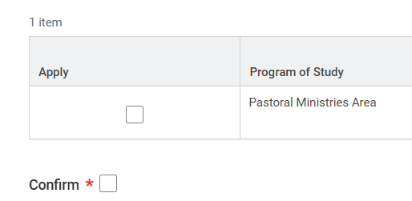
  - Click Submit
  - Click Done
- You should receive a Graduation Application Questionnaire in your inbox (top right side)

- Please complete the whole questionnaire and submit. Your application for graduation is not completed until you have successfully submitted the questionnaire.
- After you have submitted the questionnaire, you should see your answers by clicking on the Menu button (top left corner), Student, Academic, General Help – Graduation Application Answers.
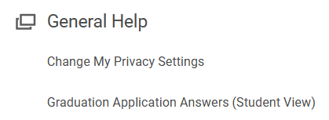
- How to know if you’ve completed all the steps? Review the Overview tab and see that it has “Pending Completion” as the status for all your program(s) of study and you should find your questionnaire answers, as stated in #5. If both are there… then you have successfully applied for graduation. Congratulations!
- If you need to make edits to your questionnaire, such as diploma address: type in “Edit My Program Completion Application”. You will receive another questionnaire, which will need to be fully completed again and submitted.
Your advisor can also see that you have completed both of these steps by noting the “Pending Completion” Status and reviewing your questionnaire. Continue to work with your advisor, following your Academic Progress to make sure all the requirements for your program(s) of study will be shown as “Satisfied” by the end of your last semester. You will not receive an “audit” from our office – as all the requirements are built out for full transparency in Workday. As always, continue to review your Academic Progress and compare your requirements as listed in the Academic Catalog, located on the website at https://catalog.campbellsville.edu/.
Once the administration sets all the ceremony dates, times, and details, you will start receiving emails from cugraduation@campbellsville.edu to your CU email. This will include all information on caps, gowns, and regalia.
Thank you and congratulations on reaching this milestone!

