Changing Photo Steps
- From the homepage, click the person icon (or photo) in the upper right-hand corner of the page.

- Click View Profile.
- Click Actions.
- Click Personal Data > Change My Photo
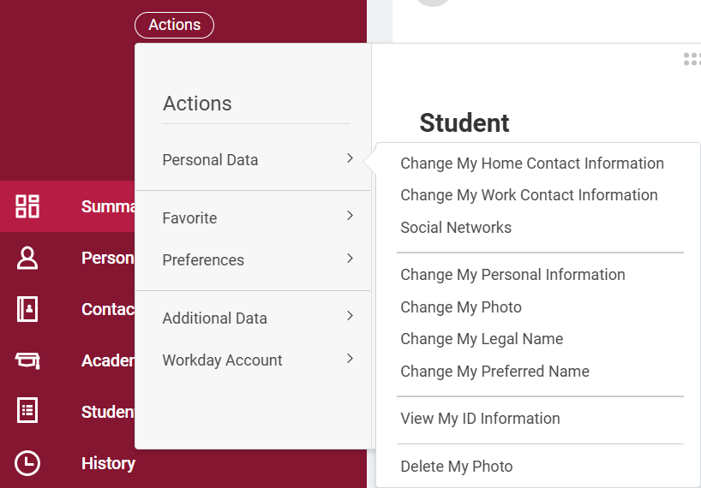
- Make sure to follow the Workday Photo Guidelines.
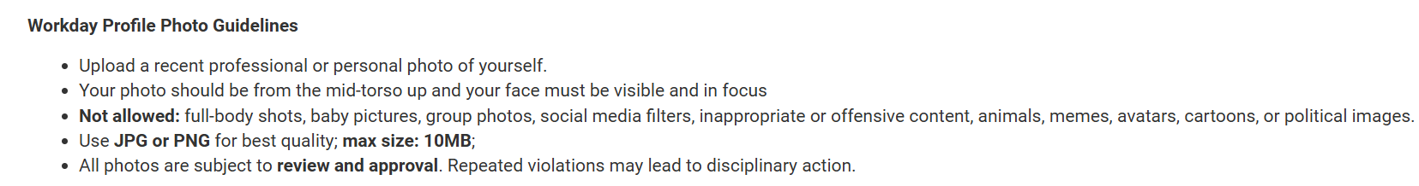
- Select the file to upload.
- Click Submit.

