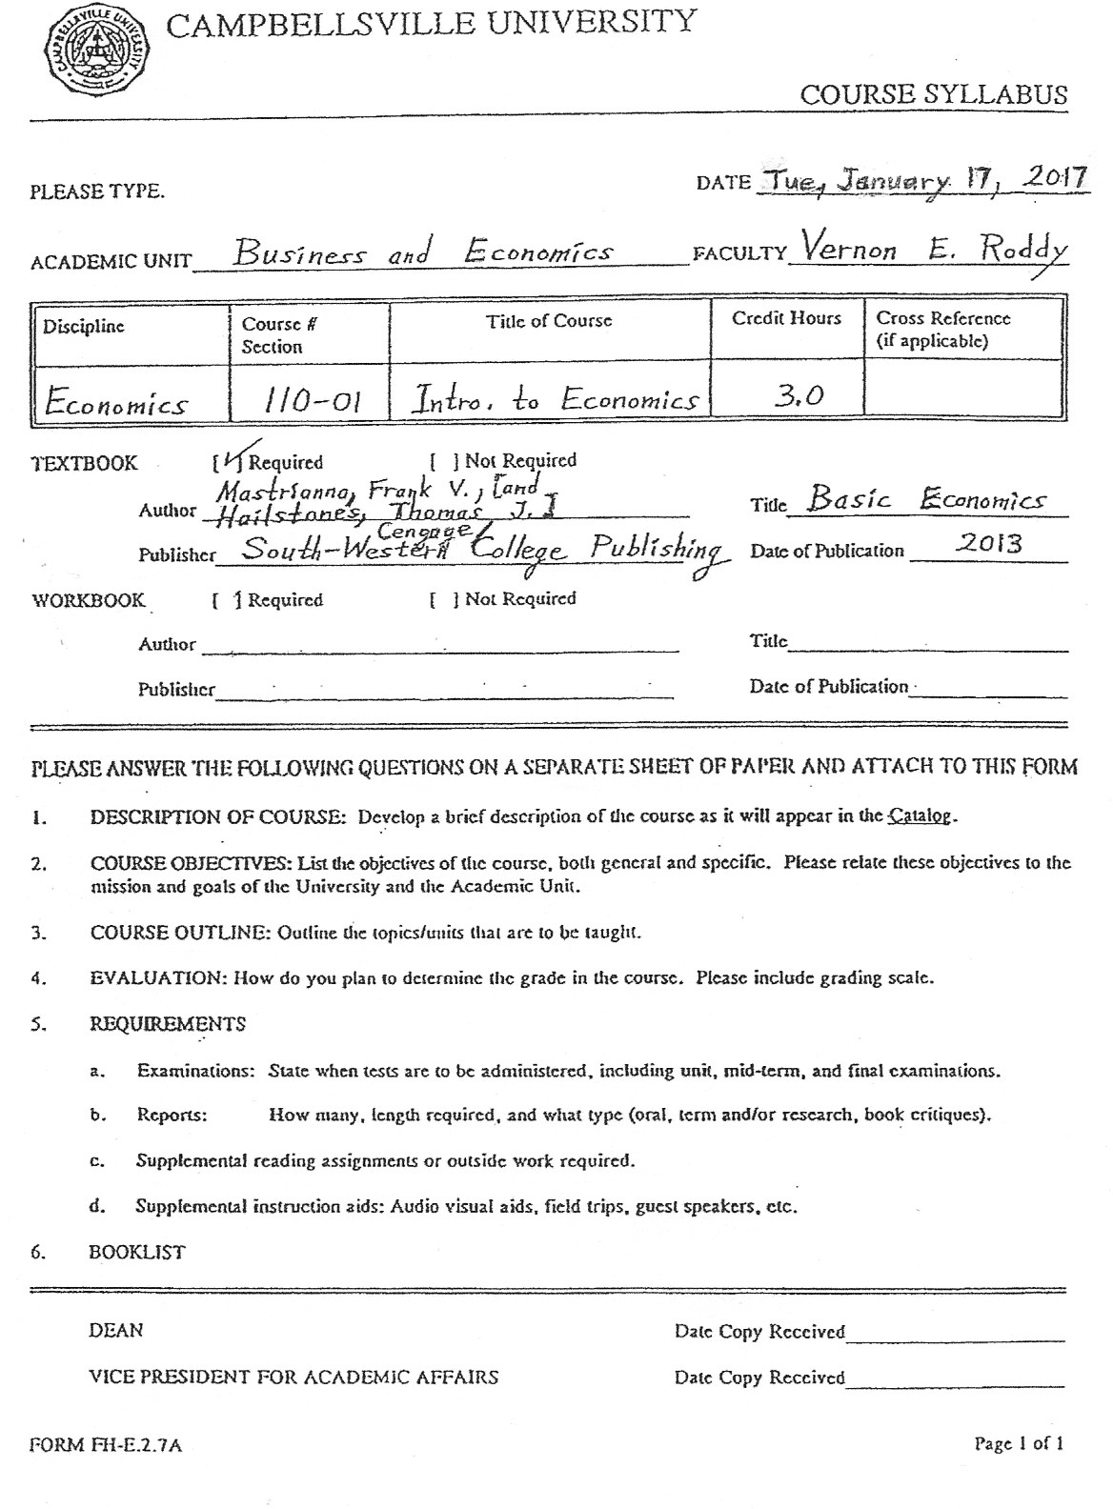

ECONOMICS 110:
INTRODUCTION TO ECONOMICS:
Principles and Theories of Capitalist System, Pricing Process, National Income
and Employment Determination, Monetary and Fiscal Policy.

Campbellsville University
Spring Term
2017.
Instructor: Vernon Roddy. C.U. Security Cell Phone: 270-403-3611
Office: Administration Building, Room 29-A. C.U. Security Office Phone: 270-789-5555
Office Hours: 11--12:05 MWF, 2--3:00 MW, 9:20--10:50 Tue. & Thurs.; accommodative other times.
---------------------------------------------------------------------------------------------------------------------------------

BASIC TEXT: Mastrianna, Frank V. Basic Economics. 16th Edition. Mason, Ohio: South-
Western/ Cengage Learning, 2013.

OTHER BOOKS: Heilbroner, Robert L. (1919--2005). The Worldly Philosophers: The Lives, Times,
and Ideas of the Great Economic Thinkers. Revised Seventh Edition. New York, N.Y.: Simon &
Schuster, Inc., 1999. (First edition was in 1953).

Smith, Adam (1723--1790). An Inquiry into the Nature and Causes of the Wealth of
Nations. (1776). Reprint: New York, N.Y.: Random House, Inc., 1937.

Keynes, John Maynard (1883--1946). The General Theory of Employment, Interest, and
Money. (1936). Reprinted: New York, N.Y.: Harcourt, Brace & World, 1965.

Lee, Susan. Susan Lee’s ABZ’s of Economics. New York, N.Y.: Poseidon Press, 1987.

Pool, John C., and Ross M. LaRoe. The Instant Economist. Reading, Massachusetts:
Addison-Wesley Publishing Company, 1985+.

Eggert, Jim. Invitation To Economics: A Friendly Guide Through the Thickets of “The
Dismal_Science.” Los Altos, California: William Kaufmann, Inc., 1984. Or, the 2nd Edition, Mountain
View, California: Mayfield Publishing Company, 1991.

Gonick, Larry. The Cartoon History of the United States. New York, N.Y.: Harper Collins,
Publishers, 1991.
Gorman, Tom. The Complete Idiot’s Guide to Economics. Indianapolis, Indiana: Alpha
Books/ Penguin Group (USA), Inc., 2003; Second Edition, 2011.
(See "Other References" at the end.)

GRADING: Exam 1: 17%; Exam 2: 17%; Exam 3: 17%; Exam 4 (final): 17%;
Class Participation, Quizzes, Exercises, Essays: 32%. A regular decimal scale is used in assign-
ing letter grades: 90 and over =A range; 80-89 =B range; 70-79 =C range; 60-69 =D range; and
below 60 =F range. No make-ups for missed Quizzes/Exercises (but they can be excused).
THE UNIVERSITY policy on all absences from class will be followed. Class attendance is encouraged,
expected, and assumed, and is directly rewarded through the category of Class Participation.
Attendance and grade updates will be available on a timely basis for each student individually.
IT IS HOPED that horizons are expanded in this course for all concerned.

COURSE OBJECTIVE(S): To gain a basic understanding of the central concepts, standard terminology,
and methodological approach of economics as a scientific endeavor, through individual study and
classroom participation; and to become more aware of the social and political roles of economic
theory and government activity---in learning how capitalism and other socioeconomic systems work.
CATALOG DESCRIPTION: “The present economic system; price-making forces; production,
consumption, distribution of goods and services; wealth, money, credit, banking, public finance;
capitalism and other economic systems are studied in this course.”
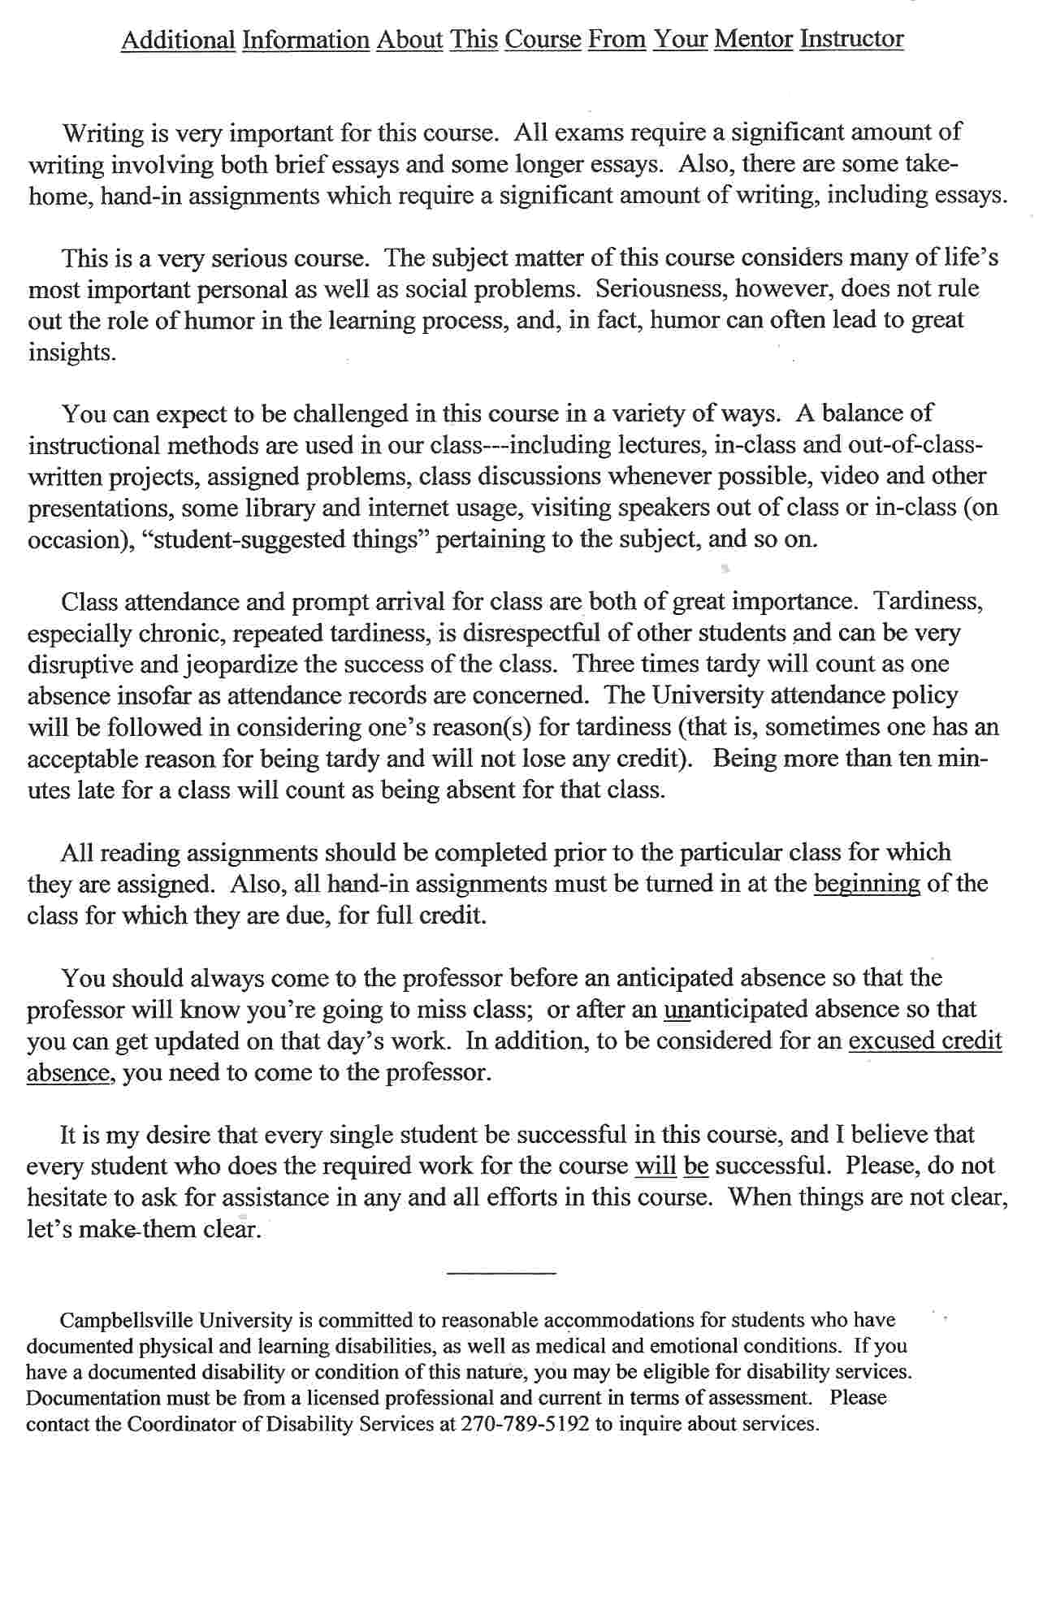
Course Contributions to General Education Objectives (Some):

1. Through directed study and discussions of the ideas of Adam Smith (1723--1790), John
Maynard Keynes (1884--1946), Francois Quesnay (1694--1774), and other "greats" in socio-
economic literature, students are given opportunities to develop and demonstrate, in discus-
sions and written assignments, understanding of some of the classic modes of creative
expression---ideas often aesthetically pleasing if not also immediately practical in the
everyday business aspects of life.

2. In discussions and in completion of specific written assignments, students are given
opportunities to demonstrate the ability to think analytically, logically, and scientifically about
economic information presented in written, graphical, mathematical, and oral forms (supply
and demand analysis being especially developed in both its micro and macro forms).

3. By facing model issues involving some key economic problems (such as unemployment) and
actions of individuals that are members simultaneously of various social groups, students are
given opportunities to demonstrate, in discussions and written assignments, an understanding
of the relationship of the individual to society---economics being one of the major social
sciences promoting social thinking.

4. By examining the "goodness" of individual economic actions in relation to the "goodness" of
social outcomes---a classic moral issue---the historically moral science of western economics
structures a process which gives students opportunities to better empathize with others, and,
thus, examine and demonstrate, in discussions and written assignments, an understanding of
certain Christian values and ethical standards, and make more informed decisions concerning
moral issues.

5. In discussions and in completion of specific written assignments, students are given oppor-
tunities to develop and demonstrate an improved ability to express ideas, beliefs, and
information in an organized, precise, and persuasive manner---beginning with a two-page
written assignment to interpret/critique the reading "Economics Is About People" (which
type of assignment also emphasizes achievement of General Education goal three above).

6. By using certain graphical analysis, elementary algebraic formulae and manipulation, and
especially, rigorous categorization on an almost daily basis, students are given opportuni-
ties to develop and demonstrate, in discussions and specific written assignments, the ability
to understand and utilize mathematical and logical relationships---in analyzing data,
constructing and assessing arguments, and making sound judgments in quantitative
situations (such as in buying and selling situations) that arise in daily economic life.

7. Through study and discussions of the citizen in his/her various economic roles in society
(especially in the United States)---as worker, consumer, and voter, for example---
students are given opportunities to develop and demonstrate in written assignments an
understanding of ideas of personal and social responsibility in a changing global economy, so
that students can make contributions to their respective discipline(s) and to society as a
whole if they so choose.

NOTE that economics deals with certain everyday events and situations which often
make the news, either locally, regionally, nationally, or internationally. A habit on
the part of the student of reading a couple of national news magazines each week
(such as Time, Newsweek, Business Week, etc.) and also of checking in on the daily
news on a regular basis (newspapers, television, etc.) can greatly enliven and give
perspective to the issues and analysis which we take up in class. Your professor
will attempt when possible and seemingly appropriate to incorporate current
happenings into this course, and he asks for your help in doing so. A sense of
history is important here, also, and the more history your read, the better for your
economics learning. The University library is your friend and should be visited
often, either in person and/or electronically.

-------------------------------------------------------

Campbellsville University and its faculty are committed to assuring a safe and productive educational environment for all students. In order to meet this commitment and comply with Title IX of the Education Amendments of 1972 and guidance from the Office for Civil Rights, the University requires all responsible employees, which includes faculty members, to report incidents of sexual misconduct shared by students to the University’s Title IX Coordinator.

Title IX Coordinator:
Terry VanMeter
1 University Drive
UPO Box 944
Administration Building, Office 8A
Phone –270-789-5016
Email – twvanmeter@campbellsville.edu

Information regarding the reporting of sexual violence and the resources that are available to victims of sexual violence is set forth at: www.campbellsville.edu/titleIX

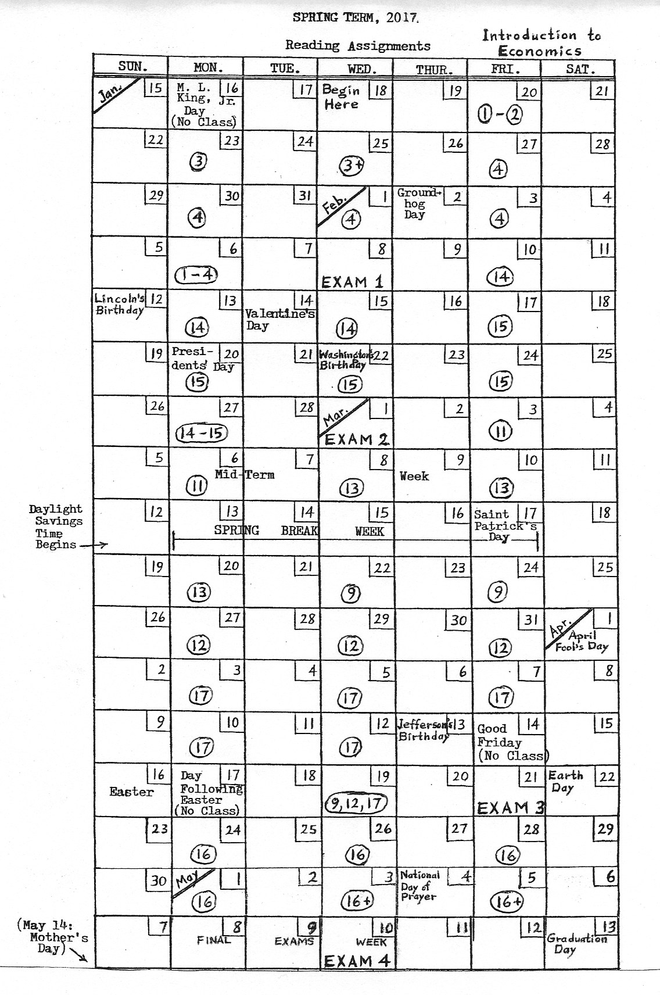

GENERAL OUTLINE

Economics and Economic Systems.

1. The Nature and Scope of Economics.
2. Scarcity and Choice.
3. The U.S. Economic System (Chapter 3)
and The Circular Flow Model (pp. 163-165 in Chapter 11).

The Market Mechanism and Competition.

4. Price: The Role of Demand and Supply.
5. Production, Cost, and Profit. }
6. Perfect Competition. }
7. Monopoly. }
8. Monopolistic Competition and Oligopoly. }

Money, Credit, and Banking.

14. Money and the U.S. Economy.
15. The Federal Reserve and the Money Supply.

Production, Income, and Employment in a Cyclical Economy.

11. The Circular Flow Model and National Income Accounts.
13. Macroeconomic Models and Analysis.
9. The Labor Market, Employment, and Unemployment.
10. Income Distribution. }
12. Business Cycles.

Economic Activity and Policies.

17. Macroeconomic Policies---Expansionary and Contractionary.
16. Taxation, Budgetary Policy, and The National Debt.
16.5 The Changing Economic Environment.

International Economics.

18. International Trade and Aid.
19. The Balance of International Payments.

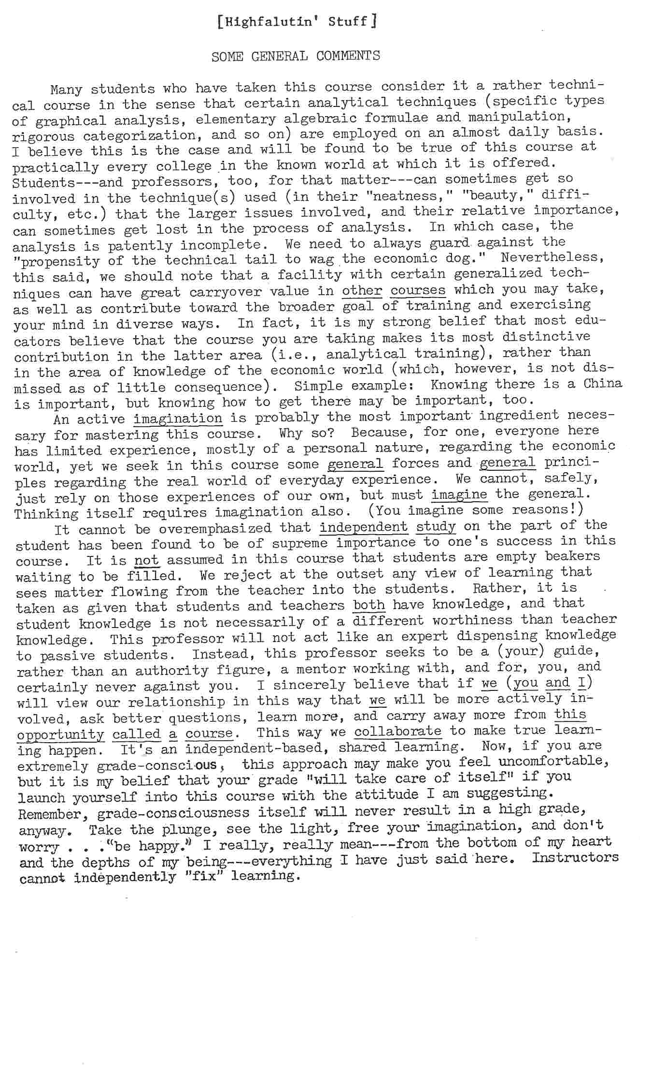
[ Highfalutin' Stuff, continued ]

MORE

The social sciences appear to be dedicated, heavily, at least, toward comprehending
(partially) what all the experience of mankind has taught or not taught us about humans as
interacting beings. Individuals---students---must, of necessity (because no one is a group),
attempt to comprehend from personal source experiences "what all the experience of mankind has
taught or not taught us." Thus, social science presents a tough personal problem which, though
never mastered completely, structures a process which possibly results in participating individuals
being able to better empathize with others, with the additional possibility that such ability coupled
with action leads to smoother conflict resolution as well as to more effective individual and group
goal achievement. Certain eminently humane, if not, indeed, Judao-Christian, goals traditionally
seem to have been suggested at Campbellsville University, but social science as science has been
considered by many to be independent of specific goals (if smoother conflict resolution is not
considered an end but only a means). Moreover, few on Earth, we believe, are against smoother
conflict resolution or more effective goal achievement, especially if it is their conflict or their
goal. To the degree that social science is taught, the above-mentioned empathic ability can be
further developed in those participating.
Economics claims to be a social science (and, in fact, is so deemed to be by Campbellsville
University). Economics focuses on the business aspects of man---"studies man in the ordinary
business of life" (Alfred Marshall). Economics presents "an engine of analysis" (Marshall) and
usually focuses on the analytical. Critical reflection is the guideword. Economics is taught as a
social science at Campbellsville University. Analytical and critical reflection skills are
emphasized at Campbellsville University.
The discipline of economics includes the special purpose of gaining knowledge and
understanding of the economic systems within which peoples live and breathe on the planet
Earth, by the use and enhancement of whatever methods seem appropriate to the task. Certain
methods are weighted more heavily than others, as previously noted. The University's
introductory economics courses all emphasize the mechanics of the capitalistic economic process,
with secondary emphasis on the justice of that same process. The discussion of economic
systems more generally is also built into these courses. Some professors specify and pursue the
additional purpose of delineating the boundaries of the economic realm, hopefully broadening
and deepening their and their students' individual awareness of self and of individual and social
values in the process, giving travelers greater ability to transcend the economic realm if they so
choose. Economics was once considered a branch of moral philosophy, and some professors
believe it still is. However, the discipline of economics is today practically silent concerning the
non-knowledge, non-skill purposes. The degree of development of self-understanding and of
values (and of which values) depends heavily on the professor and students, and there is no
separate school-sponsored procedure for ensuring any specific degree of achievement of these
latter two goals, if, indeed, they are measurable over short periods of time. The nature of the
social sciences, as argued earlier, would seem to force participating students into a type of
personal problem which requires for solution "looking beyond one's self," as well as at one's self,
and critical evaluation of one's own values in light of other held values. It is believed of
economics at Campbellsville University that the intellect employed in basic economic analysis
demands honesty, resourcefulness---which means balanced and diversified intellectual powers---
and technical competence, which is a state of mental preparation. It also requires motivation to
struggle for the more or less distant future, and it requires a polite assertiveness.

Other References

Sander, Peter. 101 Things Everyone Should Know About Economics: A Down and Dirty Guide to
Everything from Securities and Derivatives to Interest Rates and Hedge Funds---and What They Mean to
You. Avon, Massachusetts: Adams Business, 2009, 2014 (2nd edition).

Murphy, Robert P. The Politically Incorrect Guide to Capitalism. Washington, D.C.: Regnery
Publishing, Inc., 2007.

Friedman, Milton (1912--2006), with the assistance of Rose D. Friedman. Capitalism and Freedom.
40th Anniversary Edition. Chicago, Illinois: The University of Chicago Press, 2006. (1st. Ed. in 1962).

Lekachman, Robert, and Borin Van Loon. Capitalism For Beginners. New York, N.Y.: Pantheon
Books, 1981+.

Heilbroner, Robert L., and William Milberg. The Making of Economic Society. Thirteenth Edition.
Upper Saddle River, New Jersey: Pearson/ Prentice Hall, Inc., 2011. (First edition was in 1953 by RLH).

Fike, David J., and Gregg Stebben. The Pocket Professor: Everything You Need to Know About
Economics. New York, N.Y.: Pocket Books, 1999.

Marshall, Alfred (1842--1924). Principles of Economics. 8th Edition. London, England:
Macmillan, 1920. (Originally published in 1890).

Ely, Richard T., and George Ray Wicker. Elementary Principles of Economics, Together With A
Short Sketch of Economic History. Revised. New York, N.Y.: The Macmillan Company, 1919. (First
edition was in 1904.)

Ely, Richard T. An Introduction to Political Economy. New York, N.Y.: Chautauqua Press, 1889.

Kuhn, W. E. The Evolution of Economic Thought. Second Edition. Cincinnati, Ohio: South-
Western Publishing Company, 1970+.

The Wit and Wisdom of Benjamin Franklin. New York, N.Y.: Barnes & Noble Books, 1995.

Fernandez-Armesto, Felipe. Ideas That Changed The World. London, England:
Dorling Kindersley, 2003; New York, New York: Fall River Press, 2009.

Choate, Pat. Dangerous Business: The Risks of Globalization For America. New York, N.Y.:
Alfred A. Knopf, a division of Random House, Inc., 2008.

Mason, Anthony, and edited by Helen Douglas-Cooper, et al. The 20th Eventful Century: Modern
Times, 1970—1999. Pleasantville, New York: The Reader’s Digest Association,, Inc., 1999.

Tames, Richard, and edited by Helen Douglas-Cooper, et al. The 20th Eventful Century: The Way
We Lived. London, England: The Reader’s Digest Association, Limited, 1997.

Krugman, Paul. The Return of Depression Economics and the Crisis of 2008. New York, N.Y.:
W. W. Norton & Company, 2009.

Greenspan, Alan. The Age of Turbulence: Adventures in a New World. New York, N.Y.:
Penguin Books, 2008. (New chapter: “The Current Credit Crisis”).

Stutz, Fredrick P., and Barney Warf. The World Economy: Geography, Business,
Development. 6th Edition. Upper Saddle River, New Jersey: Pearson/Prentice Hall, 2012.

Knox, Paul, John Agnew, and Linda McCarthy. The Geography of the World Economy. 6th
Edition. London, England: Hodder Arnold Publishers, 2014.

Jones, Judy, and William Wilson. An Incomplete Education: 3,684 Things You
Should Have Learned But Probably Didn't. 3rd Ed. New York, N.Y.: Ballantine, 2006.

Lerner, Abba P. (1903--1982). Everybody's Business: A Re-examination of Current Assumptions
in Economics and Public Policy. New York, N.Y.: Harper Torchbooks/Harper & Row, Pub., 1961.

Schwartz, Elaine. Econ 101 ½. New York, N.Y.: Avon Books, 1995.

Fusfeld, Daniel R. The Age of the Economist. Glenview, Illinois: Scott, Foresman and Company, 1977 (3rd edition), 2002 (9th edition published by Prentice Hall).

Marron, Donald, editor. 30-Second Economics: The 50 Most Thought Provoking Economic
Theories, Each Explained in Half a Minute. New York, N.Y.: Metro Books, 2010.

Cowen, Tyler. The Great Stagnation: How America Ate All the Low-Hanging Fruit of Modern
History, Got Sick, and Will (Eventually) Feel Better. New York, N.Y.: Dutton/Penguin Group, 2011.

Morris, Dick, and Eileen McGann. Screwed! How Foreign Countries Are Ripping America Off and
Plundering Our Economy---and How Our Leaders Help Them Do It. New York, N.Y.: Broadway Books,
a division of Random House, Inc., 2013

Maybury, Richard J. Whatever Happened to Penny Candy? A Fast, Clear, and Fun Explanation of the Economics You Need for Success in Your Career, Business, and Investments. Sixth Edition. Placerville, California: Bluestocking Press, 2010.

Roberts, Paul Craig. The Failure of Laissez Faire Capitalism and Economic Dissolution of the West. Towards a New Economics for a Full World. Atlanta, Georgia: Clarity Press, 2013.

Dorling Kindersley Publishing. The Economics Book: Big Ideas Simply Explained. London, England, and New York, New York: Dorling Kindersley Publishing, 2012.

Stossel, John. No They Can’t: Why Governments Fail—and Individuals Succeed. New York, New York: Threshold Editions, A Division of Simon & Schuster, Inc., 2012.

Leeds, Michael A., and Peter von Allmen. The Economics of Sports. 5th Edition. Boston, Massachusetts, 2015.

Holcombe, Randell G., and Andrea M. Castillo. Liberalism and Cronyism: Two Rival Political and Economic Systems. Arlington, Virginia: Mercatus Center at George Mason University, 2013.

Janssen, Sarah, senior editor, et al. The World Almanac and Book of Facts 2017. New York, New York: World Almanac Books, An Imprint of Infobase Learning, 2016 (December 6, 2016).

_____________

