Campbellsville University School of Education
ED 608 Student Teaching

Contact: Chuck Hamilton Office: EDU 124
E-mail: Clhamilton@campbellsville.edu Office Hours: M, T, W, and, F.
Security Office 270-789-5555
Security Cell 270-403-3611

THEME: EMPOWERMENT FOR LEARNING
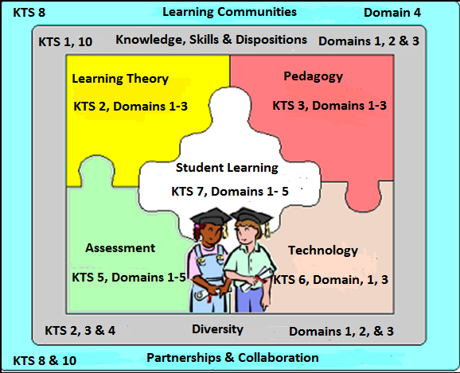

School of Education Mission Statement
In support of the institutional mission, the mission of the teacher education program is to prepare teachers for their respective fields in society by providing an academic infrastructure based on scholarship, service and Christian leadership. The primary goal of the program is to advance scholars who are competent, caring and qualified, who can positively impact student learning, and who are committed to life-long learning in a global society.

Since research has demonstrated that the teacher is most important factor affecting student learning, the teacher education program is committed to preparing candidates who are empowered and effective servant leaders in the classrooms, schools, communities and throughout the world.

The teacher education program is a performance-based process that strives to achieve this mission globally by
- preparing teachers who demonstrate the knowledge, skills and dispositions to plan, implement and evaluate instruction to assure that all students learn and perform at high levels,
- honoring, understanding, and respecting diverse voices and communities in society,
- establishing partnerships and collaborating with the professional community,
- supporting and enhancing Christian characteristics of servant leadership.

Credit Hours: 6
Prerequisite: CAP 6, Admission to Student Teaching

Description of Course
Traditional candidates who student teach are placed in cooperating accredited schools for the study of teaching in a laboratory setting. The experience consists of directed observation, guided participation and full-time classroom teaching. During this capstone experience the student teacher is under the supervision of a qualified teacher and a university supervisor. Student teaching requires one full semester (16 weeks) of classroom experience. Student teachers are required to attend regularly scheduled campus seminars in addition to their placement. (MAT traditional candidates).

The student teaching experience culminates in a real world educational evaluation model supervised by certified teachers and University Supervisors who have completed the Co-teaching Training.

A major component of the Student Teaching experience is the ​ Co-Teaching Model. This model is utilized to provide professional learning opportunities for Student Teacher Candidates in collaboration with districts/schools through a systematic process based on effective implementation practices, effective adult learning strategies, evaluation of delivery, evaluation of on-going implementation and improvement cycle analysis to promote sustainability. The outcomes of this teaching experience will focus on increasing student engagement, student achievement and supporting teacher's ability to implement with fidelity and to ultimately close achievement gaps.

Course Objectives:

KENTUCKY’S TEACHER STANDARDS
http://www.kyepsb.net/teacherprep/standards.asp

STANDARD 1: THE TEACHER DEMONSTRATES APPLIED CONTENT KNOWLEDGE

STANDARD 2: THE TEACHER DESIGNS AND PLANS INSTRUCTION
STANDARD 3: THE TEACHER CREATES AND MAINTAINS LEARNING CLIMATE
STANDARD 4: THE TEACHER IMPLEMENTS AND MANAGES INSTRUCTION
STANDARD 5: THE TEACHER ASSESSES AND COMMUNICATES LEARNING RESULTS
STANDARD 6: THE TEACHER DEMONSTRATES THE IMPLEMENTATION OF TECHNOLOGY
STANDARD 7: REFLECTS ON AND EVALUATES TEACHING AND LEARNING
STANDARD 8: COLLABORATES WITH COLLEAGUES/PARENTS/OTHERS
STANDARDS 9: EVALUATES TEACHING & IMPLEMENTS PROFESSIONAL DEVELOPMENT
STANDARD 10: PROVIDES LEADERSHIP WITHIN SCHOOL/COMMUNITY/PROFESSION
PGES – Framework for Teaching (Charlotte Danielson Model): http://education.ky.gov/teachers/PGES/Pages/PGES.aspx http://education.ky.gov/teachers/PGES/TPGES/Documents/Kentucky%20Framework%20for%20Teaching.pdf
Domain 1: Planning and Preparation
Domain 2: Classroom Environment
Domain 3: Instruction
Domain 4: Professional Responsibility

IECE Standards
http://www.epsb.ky.gov/teacherprep/iecestandards.asp

Standard I: Designs/Plans Instruction
Standard II: Creates/Maintains Environments
Standard III: Implements Instruction
Standard IV: Assesses & Communicates Learning Results
Standard V: Reflects/Evaluates Professional Practices
Standard VI: Collaborates with Colleagues/Families/Others
Standard VII: Engages in Professional Development
Standard VIII: Supports Families
Standard IX: Demonstrates Implementation of Technology

Council for Exceptional Children Standards
Standard 1: Foundations
Standard 2: Development and characteristics of learners
Standard 3: Individual learning differences
Standard 4: Instructional strategies
Standard 5: Learning environments/social interactions
Standard 6: Language
Standard 7: Instructional planning
Standard 8: Assessment
Standard 9: Professional and ethical practice
Standard 10: Collaboration
Association of Middle Level Education (AMLE)
Principle A The Learner and Learning
Standard 1: Young Adolescent Development
Principle B Middle Level Curriculum
Standard 2: Middle Level Curriculum
Standard 3: Middle Level Philosophy and School Organization
Principle C Middle Level Instructional Practice
Standard 4: Middle Level Instruction and Assessment
Principle D Professional Responsibilities
Standard 5 Middle Level Professional Roles

Council for Accreditation of Educator Programs (CAEP)
Standard 1 Content and Pedagogical Knowledge
Standard 2 Clinical Partnerships and Practice
Standard 3 Candidate Quality, Recruitment, and Selectivity
Standard 4 Program Impact
Standard 5 Provider Quality Assurance and Continuous Improvement

Interstate Teacher Assessment and Support Consortium (InTASC)
InTASC 1 Learner Development
InTASC 2 Learner Differences
InTASC 3 Learning Environments
InTASC 4 Content Knowledge
InTASC 5 Application of Content
InTASC 6 Assessment
InTASC 7 Planning for Instruction
InTASK 8 Instructional Strategies
InTASC 9 Professional Learning and Ethical Practice
InTASC 10 Leadership and Collaboration

Alignment
Course Assignments | ILA Literacy Standards | KY  Teacher Standards | CAEP &  InTASC Standards | EPSB Themes | Conceptual Framework: Theme Model*
Attendance-P-12 setting &  seminars | 1-6 | 1,2,4,5,6 | CAEP 1  InTASC 3 | Diversity  Assessment  Literacy  Closing the achievement gap | Theme: Content  Process  Self-Efficacy  Model: 1-8
Formal Observations | 1-6 | 1-10 | CAEP 1, 2  InTASC 1-10 | Diversity  Assessment  Literacy  Closing the achievement gap | Theme: Content  Process  Self-Efficacy  Model: 1-8
Video Lesson | 1-6 | 1-10 | CAEP 1, 2  InTASC 3 | Diversity  Assessment  Literacy  Closing the achievement gap | Theme: Content  Process  Self-Efficacy  Model: 1-8
Dispositions | 1-6 | 9 | CAEP 1  InTASC 3 | Diversity  Assessment  Literacy  Closing the achievement gap | Theme: Content  Process  Self-Efficacy  Model: 1-8
interview | 1-6 | 1-10 | CAEP 1  InTASC 3 | Diversity  Assessment  Literacy  Closing the achievement gap
Journal | 1-6 | 3, 4, 5, 6 | CAEP 1, 2  InTASC 1-8 | Diversity  Assessment  Literacy  Closing the achievement gap | Theme: Content  Process  Self-Efficacy  Model: 1-8
Portfolio | 1-6 | 1-10 | CAEP 1, 2,  InTASC 1-10 | Diversity  Assessment  Literacy  Closing the achievement gap | Theme: Content  Process  Self-Efficacy  Model: 1-8
ILA Standards: 1-Foundational Knowledge; 2-Curriculum & Instruction; 3-Assessment & Evaluation 4-Diversity; 5-Literate Environment; 6-Professional Learning and Leadership
Model: 1-Student Learning; 2-Learning Theory; 3-Pedagogy; 4-Technology; 5-Assessment; 6-Diversity; 7-Partnerships/Learning Community; 8-Knowledge, Skills, Dispositions

Evaluation:
Each teacher candidate can earn up to 150 points which is outlined below in the Course Requirements section. Any teacher candidate who is late submitting paper work to cooperating teachers and/or university supervisors, missing seminars and submitting the video and/or portfolio late will be penalized 5 points per calendar day. These points will be documented as deficiencies against the 150 points to be earned. The following score system will be used to determine the grade:

Total Points | Letter Grade
135-150 | A (90-100%)
120-134 | B (80-89%)
105-119 | C (70-79%)
Below 105 | F (Below 70%)

Course Requirements:
1. Exit CAP Application & Portfolio—41 points or 27% of total grade
The Exit CAP (CAP 4 or CAP 7) application including all requirements is to be submitted on the specified due date. Teacher candidates shall continue to refine and update their professional portfolios throughout the student teaching semester until the due date. Portfolios are to contain new material from the student teaching experience. The portfolio is to be available each time the University Supervisor visits.

- Journal—18 points or 12% of total grade
Teacher candidates are required to keep a journal describing, evaluating, and reflecting upon classroom experiences. The reflective journal is to be made available to the cooperating teacher and the University Supervisor. The cooperating teacher will score the journal based on a rubric of 9 points when completing the mid-term and final formal observation. If a teacher candidate has two cooperating teachers the scores will be average for a total score.

- Formal Observations—30 points or 20% of total grade
Teacher candidates are formally observed by the cooperating teacher two times at mid-term and final (some have two cooperating teachers which will make 4 observations) and by the university supervisor 4 times. For each formal observation a teacher candidate must submit the appropriate Source of Evidence forms at least 24 hours before a scheduled observation and a Source of Evidence reflection form within 24-48 hours after a scheduled observation. The university supervisor and cooperating teacher will conduct a final meeting where a summative score will be given to the teacher candidate. If a teacher candidate has two cooperating teachers, an average will be taken for the summative score. (Observation Forms and rubric are provided)

- Video Taped Lesson—18 points or 12% of total grade
Complete one twenty minute, uncut videotaping of you teaching a lesson. This lesson must include Source of Evidence 1 - 1.4, 2, 3, 4 and any assessment used during the lesson. You will be instructed how to upload your video at a student teacher seminar.

- CAP 4 Exit Program-Interview/presentation is 18 points or 12% of total grade
The program is conducted near the end of the semester. See the seminar schedule for the specific date. Students report in professional dress for a mock employment interview/presentation and a job fair. Students should bring 10-12 copies of resumes for distribution of school district representatives who will be at the fair.

- Dispositions—25 points or 16% of total grade
Cooperating teachers and university supervisors will complete a disposition form on each teacher candidate. These dispositions scores will be average for a total of 20 points.

- Seminars—Teacher candidates will be penalized 5 points or 3% of total grade for any seminar missed. (6 points for Attendance)
Student teachers shall attend all seminars. If seminars are missed teacher candidates shall be given appropriate assignments to compensate with prior approval from Student Teacher Coordinator.

- Attendance-Expected
Attend all faculty meetings, parent conference, collaborative grade-level group meetings, professional development meetings, etc. that the cooperating teacher is required to attend. Any teacher candidate who misses excessive days during the placement will be required to make them up before being approved for CAP 4.

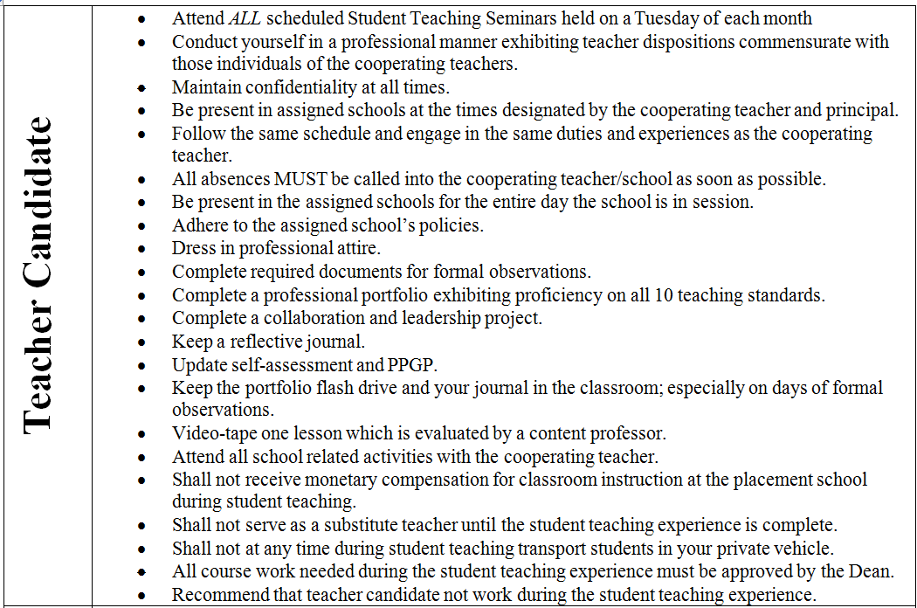

Regular attendance is expected of all candidates. It is a professional responsibility that is a part of the disposition assessment of teacher candidates. No more than five (5) absences for a 16 week placement are acceptable. Absences in excess of these numbers of days may result in an F for the course. In extreme cases doctor statements may excuse additional days beyond the five allowed. Any days beyond five, if approved by coordinator, must be made up. State statue 16 KAR 5:040 Section 6(4) states a placement must be at minimum 70 days. You must notify your university supervisor and cooperating teacher of any and all absences as soon as possible. A” Tardy” is defined as missing 10 minutes or less of school time due to late arrival or early departure. An accumulation of three tardy instances will equate to one day of absence to be applied to the course attendance policy. Anything more than 10 minutes and less than 30 minutes of missed class time will result in a half day absence. More than 30 minutes of missed class time will be considered a full day. Your arrival and departure time are as important as your regular presence. This is essential for a smooth clinical experience for you and your students and is the expectation you will face as a classroom teacher when employed later. Note: students will not be penalized for absences excused by Campbellsville University School of Education. It is also the student’s responsibility to insure that all assignments are submitted on due dates, regardless of date(s) of absences. This applies to all school related activities as part of the clinical experience

Academic Integrity (Plagiarism Policy)

Campbellsville University’s policy on Academic Integrity states: “Each person has the privilege and responsibility to develop one’s learning abilities, knowledge base, and practical skills. We value behavior that leads a student to take credit for one’s own academic accomplishments and to give credit to others’ contributions to one’s course work. These values can be violated by academic dishonesty and fraud.” (2015-17- Catalog)

Plagiarism and cheating are examples of academic dishonesty and fraud and neither will be tolerated in this course. Plagiarism is quoting or paraphrasing a phrase, a sentence, sentences, or significant amounts of text from a web or print source, without using quotation marks and without a citation. The plagiarist submits the work for credit in a class as part of the requirements for that class. Examples of cheating include cheating on a test (copying off someone else’s paper) or an assignment (e.g., development of a lesson plan) and submitting the work as your own. Examples in student teaching could include copying the development of a lesson plan, unit of study or an assessment and submitting the work as your own in the portfolio.

If a student commits plagiarism or cheats in this course, the professor will decide on one of two penalties: (a) an F on that assignment or (b) an F in the course. The student’s Dean and the Vice-President for Academic Affairs will be notified of either consequence. In addition, the student could possibly be removed from student teaching for violation of the Plagiarism Policy.

CONFIDENTIALITY
Confidentiality of children being taught or observed must be strictly adhered to at all times. NEVER mention children’s real names when discussing, sharing in online form, or with anyone else in the community, school, etc. Children, parents, and teachers must be protected! Violation of this right of children and families can cause you legal problems, loss of job, etc.
(See Student Teacher Handbook and District Policy and Procedures)
A parental permission form must be signed before administering any formal assessment procedure or taping/photographing children.
(See Student Teacher Handbook and District Policy and Procedures of Student Teacher Placement)
It is your responsibility to contact the instructor if you are having difficulty in the placement or questions pertaining to the placement. Points of Contact: Cooperating Teacher, University Supervisor, Student Teacher Coordination, and Campbellsville University School of Education Dean.

DISPOSITIONS
Cooperating Teachers and University Supervisors will complete a Disposition Form for each Student Teacher Candidate under their supervision. These documents are submitted to the School of Education and placed in each student’s file. (Contact: Student Teacher Coordinator)

INCLEMENT WEATHER POLICY
In case of inclement weather, you will follow the district’s inclement weather policy for daily attendance. If a seminar is scheduled on the day your district is not in attendance, you will follow the Campbellsville University inclement weather policy. In addition, check the Tiger Net site for the course to check for cancellation. Student Teacher Coordinator-in collaboration with the Dean of Education- will monitor the number of days in attendance for each Student Teacher Candidate placement

Disability Statement
Campbellsville University is committed to reasonable accommodations for students who have documented physical and learning disabilities, as well as medical and emotional conditions. If you have a documented disability or condition of this nature, you may be eligible for disability services. Documentation must be from a licensed professional and current in terms of assessment. Please contact the Coordinator of Disability Services at 270-789-5192 to inquire about services.
Website Resources
16 KAR 5:040. Admission, placement, and supervision in student teaching
http://www.lrc.state.ky.us/kar/016/005/040.htm

Kentucky Standards Board
http://www.kyepsb.net/certification/certstandardroutes.asp

Types of co-teaching, summarized.
http://www.specialconnections.ku.edu/?q=collaboration/cooperative_teaching/teacher_tools/types_of_co_teaching

5-minute video.
http://www.youtube.com/watch?v=TCn4qDyuZVE
5 short videos, which give examples of various co-teaching practices.
http://education.byu.edu/cpse/co_teaching/co_teach_models.html

Effective co-teaching strategies.
http://www.teachhub.com/effective-co-teaching-strategies

State-level approaches to co-teaching.
http://projectforum.org/docs/State-levelApproachestoCo-Teaching.pdf

Special Education Standards
http://www.cec.sped.org/~/media/Files/Standards/Professional%20Preparation%20Standards/Initial%20Preparation%20Standards%20with%20Elaborations.pdf

Special Education Professional Ethics Standards
http://www.cec.sped.org/Standards/Ethical-Principles-and-Practice-Standards

