Course Syllabus for POL 352: International Relations
Fall 2015

Instructor Information
Name: Shawn Williams Email: shwilliams@campbellsville.edu
Office: Druien 223 Phone: 270-789-5264
Office Hours: M-R 1:30 – 3:30 Facebook: Polly Sci

Catalog Description: This course covers the development of modern international relations, factors shaping foreign policies of nations, war, pacific settlements of disputes, and the United Nations.

Course Objectives: The objective of this course is for the student to develop an understanding and appreciation for the academic study of the interaction between nation-states and, increasingly, non-state actors. The course will focus the theoretical underpinnings of approaches to international relations, and on how to apply those underpinnings to world events past and present. By the end of the course, the student will be expected to demonstrate an understanding of:

- The differences between Realist, Liberalist, and Identity/Constructivist approaches;
- The causes and sustainers of international conflict;
- Competing explanations for the causes key world events;
- International political economy;
- The role of global monetary policy in trade; and
- The debate over globalization.

Highly Recommended Text: Nau, Henry, R. Perspectives on International Relations, 4th ed. Washington, DC: CQ Press. ISBN: 978-1-4522-4148-7

General Requirements

In this course, learning and assessment will center around five elements. First, students will take two exams designed to evaluate knowledge acquisition and application. The exams will focus on the content of lectures and student presentations. These exams will take approximately 2 hours, and may be held on more than one day.

Second, each student will participate in a least three policy analysis assignments. The purpose of these assignments will be to take the theories discussed in class and apply them to recent events. There will be several opportunities to complete these assignments over the course of the term; students may attempt more than the required number if they wish but will only be allowed to count their three highest grades. Two of these assignments will be group projects, the third will be an individual poster presentation.

Third, every student in the class will be expected to participate in an on-line game simulation. The simulation, discussed in greater detail later, will give students as players the ability to “try-out” various approaches to foreign policy using a popular board game. This game will be played in three rounds using different sets of playing conditions, and will include players from classes other than this one.

Fourth, students will be required to complete a series of assignments from the required web-text. A companion to the in-class content, the Soomo assignments are designed to provide context to the more theoretical discussions being held in class. These assignments should require about 1-2 hours per week, with some weeks requiring as little as 30 minutes. Assignments for each chapter are due on Monday (see schedule on Tigernet). There are 266 questions available from the Soomo text, spread across 51 assignments. Full credit is 200 correct answers.

Final grades will be determined using the following formula:

Unit Tests 50%
Group Policy Analyses 20%
Individual Policy Analysis 10%
Diplomacy Game Ranking 10%
Attendance/Participation 10% to -50% (or more)
100%

A= 100%-90% B= 89%-80% C= 79%-70% D= 69%-60% F= below 60%

Course Outline

Unit 1: Conflict and Conflict Resolution
- Theories of International Relations
- World War 1
- World War II
- The Cold War

Unit 2: The Modern World Order
- America: The Hegemon
- The United Nations
- The Future of Democracy?
- Identity Politics

Unit 3: Globalization in Practice
- Overview of Economics
- International Trade
- Approaches to Economic Development
- Foreign Policy and Economic Growth

Aligned with  Assessment (point values) | Kentucky Teacher Standards (KTS or IECE) | KTS Diversity Indicators | InTASC | ILA Standards | Technology (Yes or No) | [Include full name of SPA/s] | CAEP
Tests  50% | 1.1  1.2 | 1.2 | 4 |  | N | NCSS  1.1, 1.2, 1.3, 1.6, 1.8, 1.10, 2.3 | 1.3  3.5
Group policy analysis  20% | 1.1  1.2 | 1.2 | 4 |  | Y | NCSS  1.1, 1.2, 1.3, 1.6, 1.8, 1.10, 2.3 | 1.3  3.5
Individual Policy  Analysis  10% | 1.1  1.2 | 1.2 | 4 |  | Y | NCSS  1.1, 1.2, 1.3, 1.6, 1.8, 1.10, 2.3 | 1.3  3.5
Diplomacy game  10% | 1.1  1.2 | 1.2 | 4 |  | Y | NCSS  1.1, 1.2, 1.3, 1.6, 1.8, 1.10, 2.3 | 1.3  3.5
Participation | 1.1  1.2 | 1.2 | 4 |  | n | NCSS  1.1, 1.2, 1.3, 1.6, 1.8, 1.10, 2.3 | 1.3  3.5

Specific Requirements

Exams

The midterm exam will cover roughly the material in from class lecture prior to Fall Break (Unit 1 and part of Unit 2). The final exam will cover the balance of Unit 2 and some of the content in Unit 3. Each of the exams will be divided into two sections. The first section will evaluate whether the student has mastered key concepts from lectures and readings. Section 2 will consist of a questions from student presentations and the readings. Both sections will also require students to apply the content to real or hypothetical case studies. The first exam will likely be offered in two class periods, including the Tuesday of Fall Break.

Policy Analysis

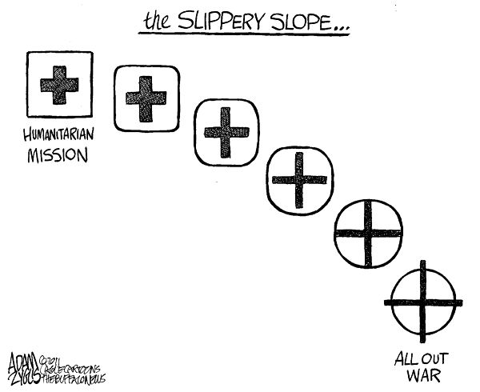
For the first three to four weeks of the course, the class will focus on helping students learn how to apply the major theories of international relations to major events of global history. Beginning in approximately week 4, students will take a greater responsibility for their own education by applying or analyzing these concepts through current issues of international concern. For each issue, students will present realist-, a liberalist-, and an identity/constructivist- based interpretations of the events or conditions that motivate the topic. Part of this presentation will require presenting background information to the rest of the class so that they can appropriately evaluate the interpretation. In addition, the students will be expected to address a series of questions particular to the issue provided by the instructor. The presentations may include and/or be followed by class discussion or an appropriate question and answer period.

Each student will have to participate in 3 PA assignments. The first two of these assignments will be group-based. For these assignments, students will be graded on the overall quality of their group effort (50%) and on their own contribution to the group presentation (50%). In addition to the instructor evaluation, student evaluations will be used calculate a score for the group and individual presentations. The survey instrument will include questions related to level of interest, speaking ability (use of notes, time management), and the quality of the content (informative, appropriate). The student evaluations will be anonymous. Participants in the group will also be allowed to comment on the relative degree of participation between members.

For the third PA assignment, each student will be responsible for their own policy analysis presentation. This presentation will be delivered in the form of a poster session. Students will be given considerable liberty to select their own topic for this assignment, and may work with the instructor to develop their own topic. If a student has not selected a topic prior to Fall break, they will be assigned a topic the week after. No two students may select the same topic; no topics may be selected prior to 9/6.

Diplomacy the Board Game

To facilitate an understanding of the Art of International Relations, students will be required to participate in a series of learning exercises. The first of these is via an online board game known as Diplomacy, originally created by Avalon Hill but currently distributed by Hasbro. Diplomacy has historically been one of the most popular games with traditional board gamers, and was one of the first board games transformed into the online age. For our purposes, each student will be required to sign-up to play via a third-party site. It will be free to play. Instructions for signing up will provided in class.

Diplomacy is a turn based game where players compete with one another to capture and control resources (known as Supply Centers) through cooperation with other players. What makes this game different from others is that the outcomes are entirely a function of strategy and negotiation. There are no dice to role, no cards to draw, and all moves happen at the same time, which means no one wins or loses simply because someone else went first. In order to succeed, players must seek assistance from their adversaries.
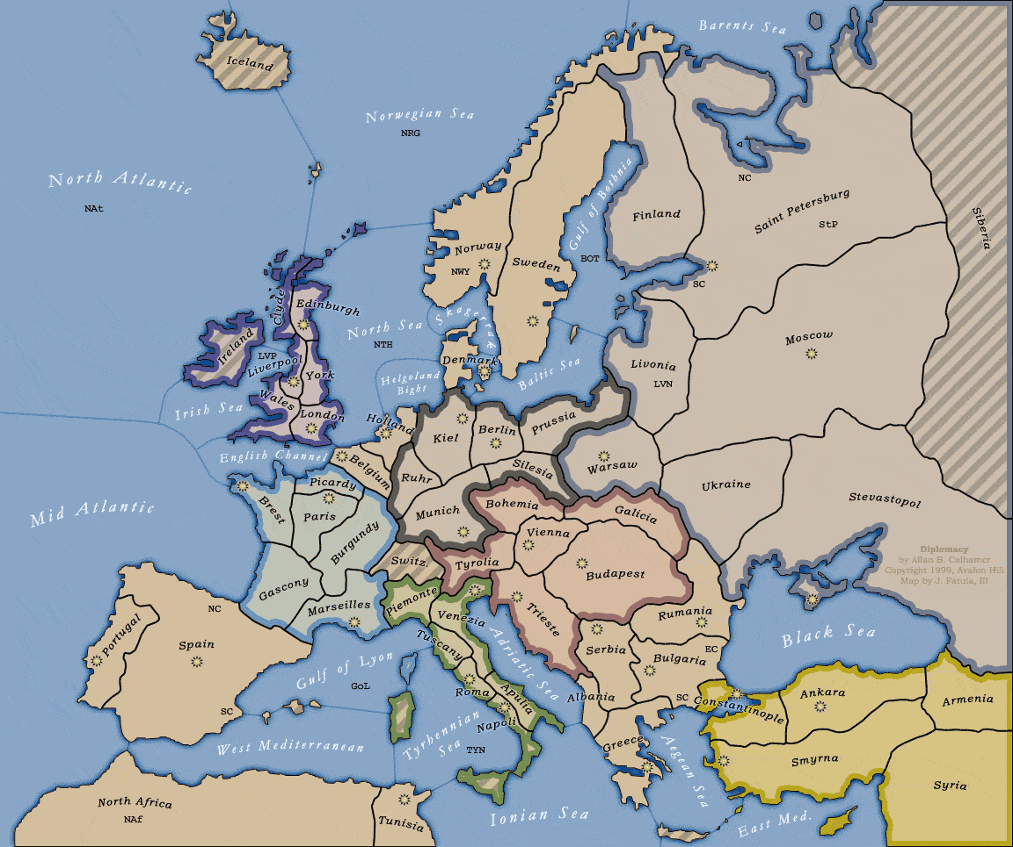
We will be using an online site for the game for a number of reasons. First, the interface provides an adjudication mechanism, which essentially means that once all players have moved, the outcome is determined automatically and doesn’t need to wait for class or for instructor input. As a result, play will continue even over weekends and breaks, and whether or not you come to class. Second, the game is timed. Players will have a fixed amount of time during which to move. If they fail to move during that period, they can be penalized and even kicked out of the game. This prevents the game from dragging to a halt because of a few players. Finally, and most importantly, the game is scored. At the beginning of each game, all players must “ante” a fixed number of points into a pot. At the end of the game, the “ante” is divided among all surviving players based on their relative strengths. Each player will be required to play three rounds against a different set of players and under different conditions. The rounds will end after 4 weeks of play (forced draw), if all surviving players agree to a draw, or if one player wins.

At the end of the term, players will be ranked based on the number of points they have earned during the term. The player with the highest score will receive a 100, the player with the lowest score will receive a 70. The grades for other players will be distributed based on the point distribution in the game. Additionally, any player who is kicked out of a game due to lack of activity will receive a 10 point deduction to their grade per incident. Finally, if a student doesn’t sign up for their assigned game, they will receive a 35 point deduction per incident.

Attendance/Participation

There are three aspects to participation in this class. First, students are expected to be in class. Attendance will be taken via roll for every class period. Students may miss three classes without penalty. For each additional absence up to 6, students will receive 1% deduction off their final grade. After the sixth absence, additional absences will be 2% of the grade. Students who fail to show up on time or who leave early will be counted as absent after the second incident.

Extra Credit

I am not a big fan of extra credit. Actually, I think it contradicts what we are trying to accomplish in the class room. I also think God disapproves of it- he is a forgiving God, not one for special favors. That said, as a gesture towards professionalization and campus unity, extra credit may be awarded to students who attend the KHIPP event on October 12, 2015. Other opportunities may exist.

Additional Expectations

In addition to the general requirements, there are also a number of specific expectations. As a student in a college level course, it is assumed that you can be held to a high standard of respect, decorum, participation, and professionalism. The classroom is more than just a place to “hang-out”; it is an institution for education. To that end, the following minimum expectations should be met by all students. Students failing to meet these expectations will see grade reductions as negative compensation for their actions. They include, but are not limited to:

Freedom of One of the most valued aspects of the collegiate environment is the right to freely express
Speech: opinions. It must be understood that this right exists in this class. To that end, it is our responsibility to respect the opinions of others, not to try to silence them. We should also be aware that some opinions expressed may not actually be held by the expresser. Upon occasion, the instructor other students may choose to take the role of “devil’s advocate” for the purpose of proving a point in the conversation. That said, it is unacceptable behavior to engage in personal attacks at any time against a classmate or against the instructor.
Use of Recording Students who wish to use recording devices in class may do so. It is recommended students sit at the
Devices: very front of the class when using such devices. In the event that this is not possible, arrangements can be worked out for using another location for recording purposes.
Requests for As a rule, the instructor does not provide notes to students. Charts, graphs or tables used in class may
Notes be made available on the instructor’s website. Students who request the instructor’s notes will be told to get them from another student.

Page of Legal Stuff

Policy on Academic Integrity
The purpose of a college education is to expand knowledge, to be exposed to different ideas, and to develop a greater understanding of the world in which you choose to live. It is expected that each student will wish to be evaluated on their own performance and not on the performance of others. If, however, a student is found to be cheating in any way, or willingly and knowingly plagiarizes the written works of others, severe consequences will follow. These will include failure of the assignment, and may include failure of the course and/or suspension from the school. To avoid this, the instructor reserves the right to move any student, or request that any student retake an exam or redo an assignment.

Disability Statement

Campbellsville University is committed to reasonable accommodations for students who have documented learning and physical disabilities, as well as medical and emotional conditions. If you have a documented disability or condition of this nature, you may be eligible for disability services. Documentation must be from a licensed professional and current in terms of assessment. Please contact the Director of Disability Services at 270-789-5192 to inquire about services.

Title IX Statement
Campbellsville University and its faculty are committed to assuring a safe and productive educational environment for all students. In order to meet this commitment and to comply with Title IX of the Education Amendments of 1972 and guidance from the Office for Civil Rights, the University requires all responsible employees, which includes faculty members, to report incidents of sexual misconduct shared by students to the University’s Title IX Coordinator.

Title IX Coordinator:
Terry VanMeter
1 University Drive
UPO Box 944
Administration Office: 8A
Phone: 270-789- 5016
Email: twvanmeter@campbellsville.edu

Campus Security

If, for any reason, you need to reach Campus security, they can be contacted at:
Office: (270) 789-5555; Cell Phone: (270) 403-3611.

Course Copyright and License

Material presented by the instructor during the course is licensed for academic purposes only, and any original content produced by the instructor should be deemed under copyright. Students may use any handouts, notes, recorded lectures, or other materials to assist them in their own learning. Students may also share course materials with students enrolled in their section to assist them in the class. Any use of the handouts, notes, recordings of any type, or any other materials developed by the instructor is a violation of this license and is subject to civil action.

Questions concerning this policy should be directed to the instructor or his designated representative.

The only exception to this rule will be students with documented disabilities.

