ED 665-01: Research Methods

**Syllabus**

**Graduate Term 1 Fall 2016**

**ED 665-01 Monday 5:30pm-6:45 pm**

**ED 665-02 Monday 7:00 pm-8:15 pm**

**ED 665-03 Tuesday 7:00 pm-8:15 pm**

**School of Education Conceptual Framework:**

**Theme: Empowerment for Learning- Content, Process, Self-Efficacy**

**EPSB Themes- Diversity, Assessment, Literacy Education, Closing the Achievement Gap**

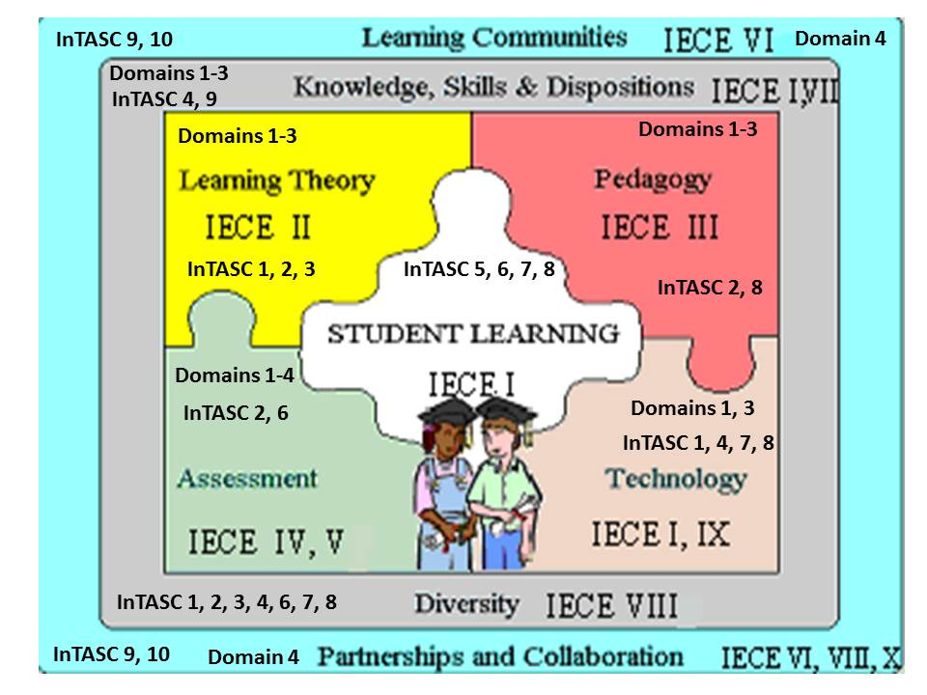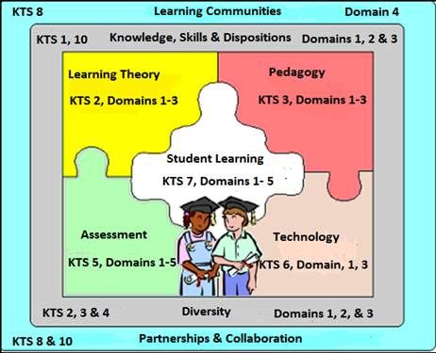

|  |  |
| --- | --- |
| Instructor | Dr. Robin Magruder |
| Office Location | EB 112 |
| Email | [rlmagruder@campbellsville.edu](mailto:rlmagruder@campbellsville.edu) |
| Office Hours | Virtual appointments at your convenience |
| Office Phone | (270) 789-5139 |
| Preferred method for contacting instructor | Email |
| Course Website | Please access this course via Learning House |
| Campus Security Cell Phone | (270) 403-3611 |
| Campus Security Office | (270) 789-5556 |
| Required Textbooks  Additional Requirements | Hendricks, C. (2013). *Improving schools through action research: A reflective practice.* New York: Pearson.  American Psychological Association (2010). *Publication Manual of the American Psychological Association Sixth Edition.* Washington D.C.: American Psychological Association.  You must have a working microphone in order to participate in weekly classroom chat sessions. |

**Course Description**

This course emphasizes both qualitative and quantitative methodology appropriate for the completion of the Teacher Leader Master’s Action Research Project. Special attention is given to action research procedures. Action research, like evaluation, policy, and pedagogical research, builds upon what is fundamental in the qualitative approach. ED 665 is one course taught in a series of six core course totaling eighteen semester hours leading to a Teacher Leader Masters of Arts in Education (MAE) degree. ED 665 is the first course in a series of three courses focusing on action research.

**Course Objectives**

**The following objectives and Kentucky Teacher Standards (KTS) performance criteria apply and Professional Growth and Effectiveness Domains (PGES):**

**KTS 1.1 (1A)** Accurately and effectively communicates an in-depth understanding of concepts, processes, and/or knowledge in ways that contribute to the learning of all students.

**KTS 3.1** **(2B)** Consistently sets significant and challenging behavioral and learning expectations for all students and communicates confidence in their abilities to achieve those expectations.

**KTS 4.2** **(3D)** Implements instruction based on contextual information and assessment data, adapting instruction to unanticipated circumstances.

**KTS 8.1** **(4C)** Designs a plan that involves parents, colleagues, and others in a collaborative effort to enhance student learning.

**KTS 10.2** **(4D)** Develops a leadership work plan that clearly describes the purpose, scope, participants involved, timeline of events/actions, and plan for assessing progress and impact.

**Additionally, the following KY Learning Goals and Academic Expectations are objectives for graduate students in this course:**

**Goal One: Students are able to use basic communication and math skills.**

1. 1 Use reference tools, especially computer programs to find information they need to meet specific requirements for this class.

* 1. Make sense of the variety of materials read for this class.
  2. Make sense of the various messages to which they listen in the graduate classroom.

1.11 Write using appropriate forms, conventions, and styles to communicate ideas and information in all experiences related to this course.

1.12 Speak using appropriate forms, convention, and styles to communicate ideas and information during class.

1.16 Use computers and other kinds of technology to collect, organize, and communicate information and ideas.

**Goal Two: Students shall develop their abilities to know curriculum foundations and principles and apply them to their teaching disciplines.**

**Goal Three: Students shall develop abilities to become self-sufficient.**

**Goal Four: Students shall develop abilities to become responsible members of a group.**

**Goal Five: Students shall develop abilities to think and solve problems.**

5.1 Use critical thinking skills to solve a variety of problems in real-life situations related to teaching.

5.3 Organize information to develop or change their understanding of a concept.

**Goal Six: Students shall develop abilities to connect and integrate experiences and new knowledge from all subject matter fields.**

**Additional Course Goals and Objectives:**

Through classroom activities which include lecture, discussion, cooperative learning group sessions, review of current literature, group reports, and presentation of papers, students are expected to achieve the following:

1. Become knowledgeable in the field of research.
2. Complete and obtain IRB approval.
3. Complete the first three sections of the MARP based on the topic selected in ED 655.

**Students will demonstrate an understanding of the following Professional Growth and Effectiveness Domains:**

* Domain 1, Planning and Preparation, 1a, 1b, 1c, 1d, 1e, 1f
* Domain 2, Classroom Environment, 2c
* Domain 3, Instruction, 3a, 3b, 3c, 3d, 3e
* Domain 4, Professional Responsibilities, 4a, 4b, 4e, 4f

**Students will demonstrate an understanding of Kentucky Core Assessment Standards and College Readiness Standards:**

Students will use the appropriate Kentucky Core Assessment Standards in designing learning goals/objectives and assessments based on their own content areas.

|  |  |  |
| --- | --- | --- |
| **Disabilities**  Campbellsville University is committed to reasonable accommodations for students who have documented physical and learning disabilities, as well as medical and emotional conditions. If you have a documented disability or condition of this nature, you may be eligible for disability services. Documentation must be from a licensed professional and current in terms of assessment. Please contact the Coordinator of Disability Services at 270-789-5192 to inquire about services.  **Notice: Any student with a disability or mental condition that may require special assistance or accommodations should discuss these with the instructor at the beginning of the semester.**   |  | | --- | | **Academic Integrity (Plagiarism)** | | Campbellsville University’s policy on Academic Integrity states, “Each person has the privilege and responsibility to develop one’s learning abilities, knowledge base, and practical skills. We value behavior that leads a student to take credit for one’s own academic accomplishments and to give credit to others’ contributions to one’s course work. These values can be violated by academic dishonesty and fraud.” (Student Handbook)  Plagiarism and cheating are examples of academic dishonesty and fraud and neither will be tolerated in this course. Plagiarism is quoting or paraphrasing a phrase, a sentence, sentences, or significant amounts of text from a web site or printed source without using quotation marks and without a citation. The plagiarist submits the work for credit in a class as part of the requirements for that class. Examples of cheating include cheating on a test (e.g., copying off someone else’s paper) or an assignment (e.g., developing a lesson plan) and submitting the work as your own.  If a student commits plagiarism or cheats in this course, the professor will decide on one of two penalties: (a) an F on that assignment or (b) an F in the course. The student’s Dean and the Vice-President for Academic Affairs will be notified of either consequence.  **Title IX Statement**  Campbellsville University and its faculty are committed to assuring a safe and productive educational environment for all students. In order to meet this commitment and to comply with Title IX of the Education Amendments of 1972 and guidance from the Office for Civil Rights, the University requires all responsible employees, which includes faculty members, to report incidents of sexual misconduct shared by students to the University's Title IX Coordinator.  Title IX Coordinator:  Terry VanMeter  1 University Drive  UPO Box 944  Administration Office 8A  Phone – 270-789-5016  Email – twvanmeter@campbellsville.edu  Information regarding the reporting of sexual violence and the resources that are available to victims of sexual violence is set forth at: [www.campbellsville.edu/titleIX](http://www.campbellsville.edu/titleIX)  **Satisfactory Academic Progress Policy (Graduate)**  Federal regulations require that all students who receive any federal or state financial assistance make measurable academic progress toward a degree at Campbellsville University. Progress is determined quantitatively (hours attempted versus hours earned and time frame) and qualitatively (GPA). Progress is monitored at the conclusion of spring and summer semesters. Those students readmitted to Campbellsville will be evaluated for SAP upon registering for classes. | |
| **Campbellsville University’s Online Course Attendance Policy 8-week terms:**  Online students must participate weekly as defined by the professor in the syllabus. After 1 week (12.5%, 1/8th of the scheduled classes) without contact the student will be issued an official warning. After the second week (25%, 1/4th of the scheduled class) without contact the student would fail the course and a WA would be recorded.  **Class Participation (KTS 6, 7, 8, 9)**  Class attendance will be checked. More than two unexcused absences (at instructors discretion) results in an automatic “F” for the course. Students will be graded on their ability to ask pertinent questions and critically discuss issues related to the learning activities of the class (small and large group online discussions, study questions, and reflective writing assignments). Please notify the instructor if you are to be absent. **Students must contribute to class discussions a minimum of five times; they should also contact the professor in advance if they might be absent.**  **Participation and Professionalism**  You are responsible for your own education. Each student is valuable to the success of this course. To be engaged, you need to participate, that is, speak. To participate, you must attend.  Communication during and outside of class will be primarily online; therefore, it is important that class members practice **netiquette**—the rules for polite and effective online communication. Some important rules to keep in mind as you participate in the **online class sessions** are:   * Keep your microphone muted when you are not speaking. This will keep distracting background noise to a minimum and also eliminate echoing when other classmates are speaking. * Do not make comments in the chat box while the professor or other students are speaking during class. It is distracting to the speaker and other students.   Some important rules to keep in mind as you participate in the **discussion forums** and **online chat** are:   * Be friendly and positive. In online communication, it is not possible to view facial expressions and body language or to hear the tone and volume of the voice, so messages may be misinterpreted. * Avoid using sarcasm, and make sure humor is “G” rated and appropriate for all audiences. Profanity will not be tolerated. * Avoid using slang. Do not type in all capital letters—it appears that you are yelling at your audience. * Be professional. Avoid using smiley faces and other emoticons in responses. Do not use abbreviations used in text messages.   **Discussion Forum Guidelines**  **Discussion forum posts are due by Thursday at 11:55 pm. You do not have to respond to each other in this course.**  Forum responses will be evaluated using the following criteria:  Initial Response 4points   |  |  |  |  |  |  |  |  |  |  | | --- | --- | --- | --- | --- | --- | --- | --- | --- | --- | | **Category** | **10** | | **8** | | | **5** | | **3** | | | **General Assignment** | All topics introduced in the prompt are **fully** addressed. | | All topics introduced in the prompt are addressed. | | | Some topics introduced in the prompt are addressed. | | The prompt is not addressed in the response. | | | **Length** | More than 10  complex sentences. | | 7-10 complex sentences | | | 4-6 sentences. | | 1-3 sentences | | |  | | | | |  | | | | | | | **Support** | | Arguments and/or statements are logical and supported by information from the text and articles. | | Arguments and/or statements are logical but made with little or loose support from the text and articles. | | | Arguments and/or statements are logical but not supported. | | Arguments and/or statements are not logical. | | | **Connections** | | Response makes clear connections to current or past experiences in the classroom, school, or political environment. | | Response makes loose connections to current or past experiences in the classroom, school, or political environment. | | | Response makes little real life connection. | | No attempt is made to connect prompt to real life situations. | | | **Mechanics** | | Response is free from grammatical, spelling, or punctuation errors. | | A few grammar, spelling, or punctuation errors exist, but they do not impact the understanding of the reader. | | | Several grammar, spelling, and punctuation errors exist. | | Grammar, spelling, and punctuation errors impede the understanding of the reader. | | |

**Grade Calculation**

Assuming punctual, regular attendance and effective participation, grades will be determined using the following scale:

|  |  |
| --- | --- |
| Percentage | Grade |
| 93 -100% | A |
| 85 - 92 % | B |
| 78 - 84% | C |
| 72 – 77 % | D |
| 71% or below | F |

Whole letter grade (A-F) will be earned. Students must earn at least a C grade in all education classes or they will have to be repeated.

**Instructions for Required Assignments**

**Submission of Assignments**

Assignments are to be typed in double space format using 12 point Times New Roman font and saved in .doc, .docx, or .pdf format. PLEASE DO NOT SUBMIT MAC DOCUMENTS AS I CANNOT OPEN THEM. Please save your documents in the following format: ***Last name_first name_ assignment*, for example, *Magruder_Robin_Philosophy*.** Margins should be no less than one inch on all sides. Please include name, course, assignment title, and date in top right corner of first page and include last name as a header of the following pages.

Assignments will be preferably uploaded to Learning House. See syllabus schedule of activities for specific information on assignment submissions.

Assignments are due at 11:55 pm on announced due dates. Students can expect to lose 5 points for each day an assignment is late. Assignments are due on the due date even if you are absent.

**PLEASE DO NOT ASK FOR EXTRA CREDIT OPPORTUNITIES, DO YOUR BEST ON ALL ASSIGNMENTS DURING THE SEMESTER.**

**Attendance and Participation (80 points)**

**Assignment One: Research Topic Selection/Annotated Bibliography (60 points)**

Complete the chart available on Learning House, Research Topic Selection.

**Assignment Two: IRB Proposal**

**(100 points)**

Complete IRB proposal following guidelines discussed in class. (See sample IRB on Learning House and power point presentation related to IRB proposal.)

**Assignment Three: Methodology and Reflection**

**(90 points)**

Refer to MARP guidelines on Moodle for methodology requirements. (See power point presentation on Learning House for important information regarding the Methodology.) In addition to turning in methodology, turn in the MARP scoring rubric as a self-assessment and the three self-reflection questions.

**Assignment Four: Introduction and Reflection**

**(65 points)**

Refer to MARP guidelines on Moodle for introduction requirements. (See power point presentation on Learning House for important information regarding the Introduction.) In addition to turning in introduction, turn in the MARP scoring rubric as a self-assessment and the three self-reflection questions.

**Assignment Five: Field Hour Requirements**

**(100 points)**

Complete field hour requirements based on the Field Hour Matrix:

Design a research question. (1 hour)

Collaborate with a building principal and discuss possible ways to investigate the research question in their building. (2 hours)

Collaborate with a classroom teacher to discuss the logistics of implementing the research.

(2 hours)

Write a draft of the letter of consent that will be send in ED 670. (1 hour)

The reflection should address the following questions:

1. What did I do well while working on the MARP?
2. What do I need to work on in the next courses related to the MARP?
3. What resources do I need to meet these needs?
4. What did I learn about myself as a learner by working on the MARP?
5. What skills did I develop by working on the MARP?
6. How did my thinking about action research and my topic change as a result of working on the MARP?
7. What questions do I still have about the MARP?

**Weekly Discussion Forum**

**(70 points total)**

Participation in discussion forums includes an initial response to the discussion forum prompt provided by the professor. For the purposes of this course, you do not have to respond to others in the class. Discussion forums are based on readings for the course and are designed to begin the conversation about the course content for the week. They prepare students for the activities and assignments for the week, so it is crucial for the class that they are completed during the week they are assigned. For this reason, **students will not receive credit for discussion forums that are completed late for any reason.**

**The tentative Schedule of Topics, Required Readings, and Assignments follow this page. A summary of the assignment due dates and exams dates are outlined below. Please refer to assignment descriptions, found at the end of this document, for specific assignment details.**

**Tentative Schedule of Topics and Required Reading**

*The instructor reserves the right to modify this schedule as necessary. Students will receive adequate notice if this occurs.

|  |  |  |  |
| --- | --- | --- | --- |
| **Date** | **Topic Emphasized** | **Required Reading**  **(Should be complete prior to class)** | **Assignments and Due Dates** |
| **Week One**  VIRTUAL- NO CLASS MEETING | Introductions  Master’s Action Research Project (MARP)  Introduction to Action Research  Defining a Research Topic | Chapter One: Research Methods in Education  Chapter Two: Generating Research Ideas Through Reflection  Skim the following articles:  ChanLin, L., Chou, T., & Hung, W. (2015). Bridging volunteer services and mobile teaching in the tablet reading community. Libri:  International Journal Of Libraries & Information Services, 65(4), 269-280. doi:10.1515/libri-2015-0052  Larkin, P. (2015). Say it with social media. Educational Leadership, 72(7), 66-69. | Discussion Forum Week One,  Tell Me About Yourself posted by July 7 at 11:55 pm |
| **Week Two**  Monday, July 11 or Tuesday, July 12 | Research Methods Overview  Empirical Sources  Developing a Research Question | Chapter Three: Connecting Theory and Action: Reviewing the Literature  Chapter Four: Initial Planning of the Action Research Study  Skim the following articles:  Ciullo, S., Falcomata, T., & Vaughn, S. (2015). Teaching social studies to upper elementary students with learning disabilities: Graphic organizers and explicit instruction. Learning Disability Quarterly, 38(1), 15-26. doi:10.1177/0731948713516767  Snow, C., & O'Connor, C. (2016). Close reading and far-reaching classroom discussion: Fostering a vital connection. Journal Of Education, 196(1), 1-8. | Discussion Forum Week Two, Empirical Studies posted by Thursday,  July 14 at 11:55 pm |
| **Week Three**  Monday,  July 18 or Tuesday, July 19 | Quantitative Data Collection/  Analysis  Empirical Studies | Chapter Five: Strategies for Collecting Data  Chapter Seven: Strategies for Data Analysis  Skim the following articles:  Evans, C. (2014). Twitter for teaching: Can social media be used to enhance the process of learning?. British Journal Of Educational Technology, 45(5), 902-915. doi:10.1111/bjet.12099  Garrahy, D. A., Cothran, D. J., & Kulinna, P. H. (2005). Voices from the  trenches: An exploration of teachers' management knowledge. Journal Of Educational Research, 99(1), 56-63. | Discussion Forum Week Three, Academic Writing and APA Style posted by Thursday, July 21 at 11:55 pm  **Assignment One: Research Topic Selection/Annotated Bibliography due at**  **11:55 pm on July 24** |
| **Week Four**  Monday,  July 25 or Tuesday, July 26 | Qualitative Data Collection/ Analysis  Methodology | Chapter Six: Final Planning Before Implementation of the Study  Watch IRB power point presentation available on Learning House and be ready to ask questions in class  Skim the following articles:  ChanMin, K., Seung Won, P., Cozart, J., & Hyewon, L. (2015). From motivation to engagement: The role of effort regulation of virtual high school students in mathematics courses. Journal Of Educational Technology & Society, 18(4), 261-272.  Stanton-Chapman, T. L., & Schmidt, E. L. (2016). Special education professionals’ perceptions toward accessible playgrounds. Research & Practice For Persons With Severe Disabilities, 41(2), 90-100. | Discussion Forum Week Four, Introduction/Literature Review posted by Thursday,  July 28 at 11:55 pm |
| **Week Five**  Monday, August 1 or Tuesday, August 2 | Methodology  IRB | Watch Methodology power point available on Learning House and be ready to ask questions in class  Skim the following articles:  Adkins, M., Bice, M., Bartee, T., & Heelan, K. (2015). Increasing physical activity during the school day through physical activity  classes: Implications for physical educators. Physical Educator, 72173-184.  Evmenova, A. S., Regan, K., Boykin, A., Good, K., Hughes, M., MacVittie, N., & ... Chirinos, D. (2016). Emphasizing planning for essay writing with a computer-based graphic organizer. Exceptional Children, 82(2), 170-191. doi:10.1177/0014402915591697 | Discussion Forum Week Five, Methodology posted by Thursday, February 25 at 11:55 pm  **Assignment Two: IRB Proposal due by 11:55 on August 10** |
| **Week Six**  VIRTUAL- NO CLASS MEETING | Introduction  Validity, Reliability, and Generalizability | Chapter Five: Strategies for Collecting Data  Chapter Six: Final Planning Before Implementation of the Study  Watch Introduction power point available on Learning House  Skim the following articles:  Apel, K., & Henbest, V. S. (2016). Affix meaning knowledge in first through third grade students. Language, Speech & Hearing Services In Schools, 47(2), 148-156. doi:10.1044/2016_LSHSS-15-0050  Bola, Ł., Siuda-Krzywicka, K., Paplińska, M., Sumera, E., Hańczur, P., & Szwed, M. (2016). Braille in the sighted: Teaching tactile reading to sighted adults. Plos ONE, 11(5), 1-13. doi:10.1371/journal.pone.0155394 | Discussion Forum Week Six, Data Analysis and Interpretation posted by Thursday, August 11 at 11:55 pm  **Assignment Three: Methodology and Reflection due at 11:55 pm on Sunday, August 14** |
| **Week Seven**  Monday,  August 15 or Tuesday, August 16 | Validity, Reliability, and Generalizability  Methodology | Chapter Eight: Writing and Disseminating the Action Research Report | Discussion Forum Week Seven, Academic Writing/APA Style posted by Thursday, March 10 at 11:55 pm  **Assignment Four: Introduction and Reflection due by 11:55 pm on Wednesday,**  **August 17**  **Assignment Five: Field Hours due by 11:55 pm on Sunday, August 21** |
| **Week 8**  Monday, August 22 or Tuesday, August 23 | Review of Action Research |  | **Revisions of Introduction and Methodology will be accepted until Wednesday, August 24 at NOON in order to improve your grade. After that point, your original grades on these documents will be posted.** |